**Online School**

**PROJECT REPORT**

***Submitted by***

Santosh N

**[Reg No. 12406212]**

***in partial fulfillment for the award of the degree***

***of***

**Bachelor of Technology**

**IN**

**Computer Science and Engineering**



**Lovely Professional University, Punjab**

**October 2024**

**TABLE OF CONTENTS**

|  |  |  |
| --- | --- | --- |
| **Sr. NO.** | **Content** | **PAGE NO.** |
| **1** | **Title Page** | **1** |
| **4** | **Table of Contents** | **2** |
| **3** | **Introduction** | **3** |
| **4** | **Technology Used** | **4** |
| **5** | **Workflow** | **5** |
| 6 | **Working of Project** | 6 |
| 7 | **Code Snippets of the project** | 7-22 |
| 8 | **Screenshots** | 23-24 |
| 9 | **Conclusion** | 25 |
| 10 | Reference | 25 |
|  |  |  |

|  |  |  |  |
| --- | --- | --- | --- |
|  |  |  |  |

**Introduction**

An online learning platform provides a flexible, accessible, and interactive environment for learners worldwide. These platforms leverage digital tools to deliver a wide range of educational resources, courses, and certifications, accommodating diverse learning styles and schedules. By removing traditional geographical and time constraints, online learning platforms empower users—from students and professionals to lifelong learners—to gain new skills, advance their knowledge, and achieve career goals at their own pace. Through innovative features such as interactive quizzes, video lectures, peer interactions, and personalized progress tracking, these platforms make education more engaging, effective, and tailored to individual needs.

**TECHNOLOGIES USED**

Creating an engaging and functional e-commerce website like Gaming Sphere involves utilizing a combination of technologies. In this case, HTML, CSS serve as the foundational building blocks of the website, each contributing unique features and functionalities that enhance user experience.

**HTML (HyperText Markup Language)**

HTML is the backbone of any website, providing the structure and semantic meaning to web content. In Gaming Sphere, HTML is used to create the layout of the site, including the homepage, product listings, and checkout pages. Key features include:

1. **Semantic Elements**: Utilizing elements like <header>, <nav>, <section>, and <footer> helps improve the site's accessibility and SEO (Search Engine Optimization). This organization allows search engines to better understand the content and context of the page.
2. **Forms and Inputs**: HTML forms are critical for user interactions, such as creating accounts, logging in, and processing purchases. By using various input types (e.g., text, email, number), the site ensures that user data is collected efficiently.
3. **Multimedia Integration**: HTML supports embedding images, videos, and audio files, allowing Gaming Sphere to showcase game trailers, screenshots, and product details effectively.

**CSS (Cascading Style Sheets)**

CSS is responsible for the presentation and layout of the website. It defines how HTML elements are displayed on the screen, enhancing the visual appeal and user experience. Key contributions of CSS in Gaming Sphere include:

1. **Styling and Layout**: CSS is used to create visually appealing designs with custom fonts, colors, and spacing. The responsive design ensures that the website looks great on various devices, from desktops to smartphones.
2. **Flexbox and Grid Systems**: These CSS features allow for flexible and responsive layouts. By using Flexbox for navigation and Grid for product listings, the site adapts seamlessly to different screen sizes, providing an optimal browsing experience.
3. **Animations and Transitions**: CSS enables subtle animations and transitions that enhance interactivity, such as hover effects on buttons and smooth loading animations, making the user experience more engaging.

WORKFLOW

Start

|

v

Project Planning

|

v

Providing HTML structure

|

v

Improving Design by CSS

|

v

Adding other features

|

v

Adding study material

|

v

Adding accessories and platforms

|

v

Completing Frontend of the website

|

v

End

**WORKING OF ONLINE SCHOOL**

Online learning platforms operate by providing digital access to educational content and resources through a website or app, allowing learners to study at their own pace or in real-time with instructors. Here’s how they generally work:

1. **Enrollment and Access**: Users create an account and enroll in specific courses or programs. Some platforms offer free courses, while others require a subscription or one-time payment.
2. **Content Delivery**: Course materials are delivered digitally, including video lectures, reading materials, quizzes, and assignments. Many platforms use multimedia formats to cater to different learning preferences.
3. **Interactive Features**: Many platforms include tools for interactive learning, like discussion forums, live chat, and virtual classrooms, where learners can connect with instructors and peers to discuss topics and ask questions.
4. **Assessments and Feedback**: Quizzes, assignments, and exams assess learners' understanding, providing immediate feedback. Instructors or automated systems often grade these assessments, allowing learners to track their progress.
5. **Personalized Learning Paths**: Some platforms use AI to offer personalized learning recommendations based on progress and performance, helping learners stay engaged and focused on areas that need improvement.
6. **Certification and Progress Tracking**: Upon course completion, learners often receive certificates that can be shared on professional profiles. The platform typically tracks user progress, which helps in setting learning goals and milestones.
7. **Accessibility Across Devices**: Most platforms work across devices, allowing learners to access their courses from a desktop, tablet, or smartphone, providing flexibility to learn anytime, anywhere.

Code Snippets

HTML:

<!DOCTYPE html>

<html lang="en">

<head>

    <meta charset="UTF-8">

    <meta name="viewport" content="width=device-width, initial-scale=1.0">

    <title>online-school</title>

    <link rel="stylesheet" href="https://stackpath.bootstrapcdn.com/bootstrap/4.5.0/css/bootstrap.min.css" integrity="sha384-9aIt2nRpC12Uk9gS9baDl411NQApFmC26EwAOH8WgZl5MYYxFfc+NcPb1dKGj7Sk" crossorigin="anonymous">

    <link href="https://fonts.googleapis.com/css2?family=Poppins:ital,wght@0,100;0,200;0,300;0,400;0,500;0,600;0,700;0,800;0,900;1,100;1,200;1,300;1,400;1,500;1,600;1,700;1,800;1,900&display=swap" rel="stylesheet">

    <link rel="stylesheet" href="style.css">

</head>

<body>

    <header class="nav-scroll fixed-top mh-xss-mobile-nav">

        <div class="container">

            <nav class="navbar navbar-expand-lg navbar-light">

                <a class="navbar-brand" href="#">

                    <img src="images/o-school-high-resolution-logo-transparent.png" alt="" style="height: 20%; width: 80%;">

                </a>

                <button class="navbar-toggler" type="button" data-toggle="collapse" data-target="#navbarNav" aria-controls="navbarNav" aria-expanded="false" aria-label="Toggle navigation">

                    <span class="navbar-toggler-icon"></span>

                </button>

                <div class="collapse navbar-collapse" id="navbarNav">

                    <ul class="navbar-nav ml-auto">

                        <li class="nav-item active">

                            <a class="nav-link" href="#">Books <span class="sr-only">(current)</span></a>

                        </li>

                        <li class="nav-item">

                            <a class="nav-link" href="#course">Course</a>

                        </li>

                        <li class="nav-item">

                            <a class="nav-link" href="#others">Others</a>

                        </li>

                        <li class="nav-item">

                            <a class="nav-link" href="#">Blog</a>

                        </li>

                        <li class="nav-item">

                            <a class="nav-link nav-btn" href="#subscribe">Sign In</a>

                        </li>

                    </ul>

                </div>

            </nav>

        </div>

    </header>

    <section class="header-section d-flex align-items-center">

        <div class="container">

            <div class="row">

                <div class="col-lg-5 col-md-12">

                    <div class="header-details">

                        <h6>Are you ready to Learn?</h6>

                        <h1>Learn With fun <br> on <span>any schedule</span></h1>

                        <button class="get-btn">Get Started</button>

                    </div>

                </div>

                <div class="col-lg-6 col-md-12 ml-auto">

                    <div class="header-image">

                        <img src="images/picture/header-image.png" alt="" class="img-fluid">

                    </div>

                </div>

            </div>

        </div>

    </section>

    <section class="cards-section sec-padding">

        <div class="container">

            <div class="row">

                <div class="col-md-6 col-lg-3 col-sm-6">

                    <div class="cards-inner">

                        <img src="images/icon/book.png" alt="" class="img-fluid">

                        <h5>1500+ Topic</h5>

                        <p>Learn Anythings</p>

                    </div>

                </div>

                <div class="col-md-6 col-lg-3 col-sm-6">

                    <div class="cards-inner">

                        <img src="images/icon/students-icon-2.png" alt="" class="img-fluid">

                        <h5>1800+ Students</h5>

                        <p>Learn Anythings</p>

                    </div>

                </div>

                <div class="col-md-6 col-lg-3 col-sm-6">

                    <div class="cards-inner">

                        <img src="images/icon/paper.png" alt="" class="img-fluid">

                        <h5>9K+ Test Token</h5>

                        <p>Learn Anythings</p>

                    </div>

                </div>

                <div class="col-md-6 col-lg-3 col-sm-6">

                    <div class="cards-inner">

                        <img src="images/icon/student-icon.png" alt="" class="img-fluid">

                        <h5>2000+ Student</h5>

                        <p>Learn Anythings</p>

                    </div>

                </div>

            </div>

        </div>

    </section>

    <section class="course-section sec-padding" id="course">

        <div class="container">

            <h2 class="text-center title-text">Online Courses</h2>

            <div class="card-deck">

                <div class="card">

                    <img src="images/picture/card-1.png" class="card-img-top" alt="...">

                    <div class="card-body">

                        <h5 class="card-title">Communication Skills</h5>

                        <p class="card-text">Designation.</p>

                        <button class="buy-btn">Buy Course</button>

                    </div>

                    <div class="card-footer">

                        <div class="d-flex justify-content-between">

                            <div class="date d-flex">

                                <img src="images/icon/calendar.png" alt="">

                                <h6>Start 20  April, 2025</h6>

                            </div>

                            <div class="date d-flex">

                                <img src="images/icon/people.png" alt="">

                                <h6>60 seats</h6>

                            </div>

                        </div>

                    </div>

                </div>

                <div class="card">

                    <img src="images/picture/card-2.png" class="card-img-top" alt="...">

                    <div class="card-body">

                        <h5 class="card-title">Pyschology</h5>

                        <p class="card-text">Designation.</p>

                        <button class="buy-btn">Buy Course</button>

                    </div>

                    <div class="card-footer">

                        <div class="d-flex justify-content-between">

                            <div class="date d-flex">

                                <img src="images/icon/calendar.png" alt="">

                                <h6>Start 20  April, 2025</h6>

                            </div>

                            <div class="date d-flex">

                                <img src="images/icon/people.png" alt="">

                                <h6>60 seats</h6>

                            </div>

                        </div>

                    </div>

                </div>

                <div class="card">

                    <img src="images/picture/card-3.png" class="card-img-top" alt="...">

                    <div class="card-body">

                        <h5 class="card-title">Marketing</h5>

                        <p class="card-text">Designation.</p>

                        <button class="buy-btn">Buy Course</button>

                    </div>

                    <div class="card-footer">

                        <div class="d-flex justify-content-between">

                            <div class="date d-flex">

                                <img src="images/icon/calendar.png" alt="">

                                <h6>Start 20  April, 2025</h6>

                            </div>

                            <div class="date d-flex">

                                <img src="images/icon/people.png" alt="">

                                <h6>60 seats</h6>

                            </div>

                        </div>

                    </div>

                </div>

            </div>

        </div>

    </section>

    <section class="video-section sec-padding" id="others">

        <div class="container">

            <div class="row">

                <div class="col-md-5 d-flex align-items-center">

                    <div class="video-details">

                        <h2>Helping people grow their careers, every day!</h2>

                        <button class="get-btn">Start Learning</button>

                    </div>

                </div>

                <div class="col-md-6 ml-auto">

                    <div class="video-image">

                        <img src="images/picture/stuednt-video.jpg" alt="" class="img-fluid">

                        <a href="https://www.youtube.com/embed/b6FdqRrrMlQ" target="_blank">

                            <div class="video-icon">

                                <img src="images/icon/play.png" alt="">

                            </div>

                        </a>

                    </div>

                </div>

            </div>

        </div>

    </section>

    <section class="testimonial-section sec-padding">

        <div class="container">

            <h2 class="text-center title-text">Testimonial</h2>

            <div class="row">

                <div class="col-md-9 mx-auto">

                    <div class="testimonial-inner d-lg-flex justify-content-between">

                        <img src="images/picture/man.png" alt="" class="img-fluid">

                        <p>There are many variations of passages of courses available, but the

                            majority have suffered alteration in some form, by injected humour,

                           or randomised words which don't look even slightly believable.</p>

                    </div>

                </div>

            </div>

        </div>

    </section>

    <section class="subscribe-section" id="subscribe">

        <div class="container">

            <div class="row">

                <div class="col-md-12 col-lg-9 mx-auto">

                    <div class="subscribe-inner text-center">

                        <h2>Do you want to be an instructor?</h2>

                        <a href="mailto:mohammadsaidul2k19@gmail.com" class="get-btn">Join With Us</a>

                    </div>

                </div>

            </div>

        </div>

    </section>

    <footer class="footer-section">

        <div class="container">

            <div class="row">

                <div class="col-md-4">

                    <div class="footer-p">

                        <p>Millions of people of all ages and from around

                            the world are improving their lives with us</p>

                    </div>

                </div>

                <div class="col-md-7 ml-auto">

                    <div class="footer-inner d-flex justify-content-between">

                        <div class="footer-list-item">

                            <ul class="list-unstyled">

                                <li>Course</li>

                                <li><a href="#">Graphic Design</a></li>

                                <li><a href="#">Web Design</a></li>

                                <li><a href="#">Business</a></li>

                                <li><a href="#">Marketing</a></li>

                                <li><a href="#">Engineering</a></li>

                            </ul>

                        </div>

                        <div class="footer-list-item">

                            <ul class="list-unstyled">

                                <li>Terms</li>

                            </ul>

                        </div>

                        <div class="footer-list-item">

                            <ul class="list-unstyled">

                                <li>Useful Links</li>

                            </ul>

                        </div>

                    </div>

                </div>

            </div>

            <div class="copyright text-center">

                <small>Copyright © 2025 Programming-hero.com</small>

            </div>

        </div>

    </footer>

    <script src="https://code.jquery.com/jquery-3.5.1.slim.min.js" integrity="sha384-DfXdz2htPH0lsSSs5nCTpuj/zy4C+OGpamoFVy38MVBnE+IbbVYUew+OrCXaRkfj" crossorigin="anonymous"></script>

    <script src="https://cdn.jsdelivr.net/npm/popper.js@1.16.0/dist/umd/popper.min.js" integrity="sha384-Q6E9RHvbIyZFJoft+2mJbHaEWldlvI9IOYy5n3zV9zzTtmI3UksdQRVvoxMfooAo" crossorigin="anonymous"></script>

    <script src="https://stackpath.bootstrapcdn.com/bootstrap/4.5.0/js/bootstrap.min.js" integrity="sha384-OgVRvuATP1z7JjHLkuOU7Xw704+h835Lr+6QL9UvYjZE3Ipu6Tp75j7Bh/kR0JKI" crossorigin="anonymous"></script>

</body>

</html>

CSS:

html{

    scroll-behavior: smooth;

}

body{

    font-family: 'Poppins', sans-serif;

}

.nav-item a{

    font-size: 16px;

    line-height: 24px;

    color: #000000;

}

.sec-padding{

    padding-bottom: 80px;

}

.fixed-top{

    background: #F0FFF0;

}

.nav-item{

    padding: 0px 5px;

}

.nav-btn{

    padding: 10px 28px !important;

    background-color: #21B573;

    color: #ffffff !important;

    border: none;

    border-radius: 33px;

}

/* Header section */

.header-section{

    height: 100vh;

    background-color: #F0FFF0;

}

.header-details h6{

    color: #FD511A;

    font-weight: normal;

    font-size: 16px;

    line-height: 24px;

    margin-bottom: 10px;

}

.header-details h1{

    font-weight: bold;

    font-size: 48px;

    line-height: 70px;

    color: #000000;

    margin-bottom: 19px;

}

.header-details h1 span{

    color: #21B573;

}

.header-details p{

    font-size: 16px;

    line-height: 36px;

    color: #6C6B6B;

    margin-bottom: 15px;

}

.get-btn{

    padding: 12px 35px;

    background-color: #21B573;

    color: #ffffff;

    border: none;

    border-radius: 33px;

}

.get-btn:hover{

    background-color: #1d9660;

}

/* Cards section */

.cards-section{

    margin-top: 40px;

}

.cards-inner{

    padding: 50px 0px;

    text-align: center;

    background: #F8FFFB;

    border-radius: 10px;

    transition: all .4s;

}

.cards-inner:hover{

    background: #FFFFFF;

    box-shadow: 0px 20px 40px rgba(0, 0, 0, 0.1);

}

.cards-inner img{

    width: 65px;

    height: 83px;

}

.cards-inner h5{

    font-weight: 500;

    font-size: 24px;

    line-height: 36px;

    color: #413960;

    margin-top: 20px;

    margin-bottom: 0;

}

.cards-inner p{

    font-size: 16px;

    line-height: 24px;

    color: #585859;

    margin-bottom: 0;

}

/* course-section */

.title-text{

    font-size: 36px;

    line-height: 54px;

    color: #413960;

    font-weight: bold;

    margin-bottom: 60px;

}

.card{

    border: none;

    background: #FFFFFF;

    box-shadow: 0px 10px 40px rgba(0, 0, 0, 0.1);

    border-radius: 18px;

}

.card-img-top{

    padding: 20px;

    padding-bottom: 0;

}

.card-body h5{

    font-weight: 500;

    font-size: 24px;

    line-height: 36px;

    color: #413960;

    margin-bottom: 3px;

}

.card-body p{

    font-size: 16px;

    line-height: 24px;

    color: #585859;

    margin-bottom: 19px;

}

.buy-btn{

    padding: 8px 27px;

    background-color: #21B573;

    color: #ffffff;

    border: none;

    border-radius: 33px;

    transition: all .3s;

}

.buy-btn:hover{

    background-color: #1d9660;

}

.card-footer{

    background: #ffffff;

    border-top: 0px;

    border-radius: 18px !important;

}

.date img{

    width: 24px;

    height: 24px;

}

.date h6{

    font-weight: 500;

    font-size: 16px;

    line-height: 24px;

    color: #585859;

    margin-left: 3px;

}

/* video area */

.video-section{

    background-color: #F0FFF0;

    padding: 80px 0px;

    margin-bottom: 50px;

}

.video-details h2{

    font-size: 36px;

    line-height: 54px;

    color: #413960;

}

.video-image img{

    border-radius: 20px;

}

.video-image{

    position: relative;

}

.video-icon{

    width: 70px;

    height: 70px;

    border-radius: 50%;

    background: #ffffff;

    position: absolute;

    top: 50%;

    left: 50%;

    transform: translate(-50%, -50%);

    display: grid;

    place-items: center;

    cursor: pointer;

}

/* testimonail section */

.testimonial-inner p{

    font-weight: normal;

    font-size: 16px;

    line-height: 30px;

    margin-bottom: 0;

    padding: 15px 0px;

    margin-left: 50px;

}

/* subscribe area */

.subscribe-inner{

    background: #F0FFF0;

    padding: 50px 0px;

    border-radius: 20px;

    margin-top: 30px;

    margin-bottom: 50px;

}

.subscribe-inner h2{

    font-size: 36px;

    line-height: 54px;

    color: #413960;

    margin-bottom: 30px;

    font-weight: 600;

}

.subscribe-inner a{

    text-decoration: none;

    color: #ffffff;

}

/* Footer section */

.footer-section{

    padding-top: 55px;

    background: #282531;

    color: #FFFFFF;

}

.footer-p p{

    font-weight: normal;

    font-size: 16px;

    line-height: 30px;

}

.footer-inner{

    padding-bottom: 75px;

}

.footer-list-item ul li{

    font-size: 16px;

    line-height: 30px;

    margin-bottom: 5px;

}

.footer-list-item ul li:nth-child(1){

    font-weight: bold;

}

.footer-list-item a{

    color: #FFFFFF;

    text-decoration: none;

}

small{

    font-size: 16px;

    line-height: 30px;

    color: #CDCDCD;

}

/* Responsive Css */

@media only screen and (max-width: 1024px) {

    .header-section{

        padding-top: 80px;

    }

}

@media only screen and (max-width: 991px) {

    .header-section {

        height: 100%;

        padding-bottom: 50px;

        padding-top: 0;

    }

    .header-details {

        padding-top: 120px;

    }

    .cards-inner{

        margin-bottom: 20px;

    }

    .video-details {

        margin-bottom: 50px;

    }

    .testimonial-inner{

        text-align: center;

    }

    .testimonial-inner p{

        margin-left: 0;

    }

    .nav-btn{

        max-width: 20%;

        text-align: center;

    }

}

@media only screen and (max-width: 767px) {

    .card-deck{

        display: block !important;

    }

    .card{

        margin-bottom: 30px !important;

    }

}

@media only screen and (max-width: 575px) {

    .header-details h1 {

        font-size: 44px;

        line-height: 65px;

        margin-bottom: 15px;

    }

    .footer-list-item ul li {

        font-size: 14px;

        line-height: 26px;

    }

}

SCREENSHOTS

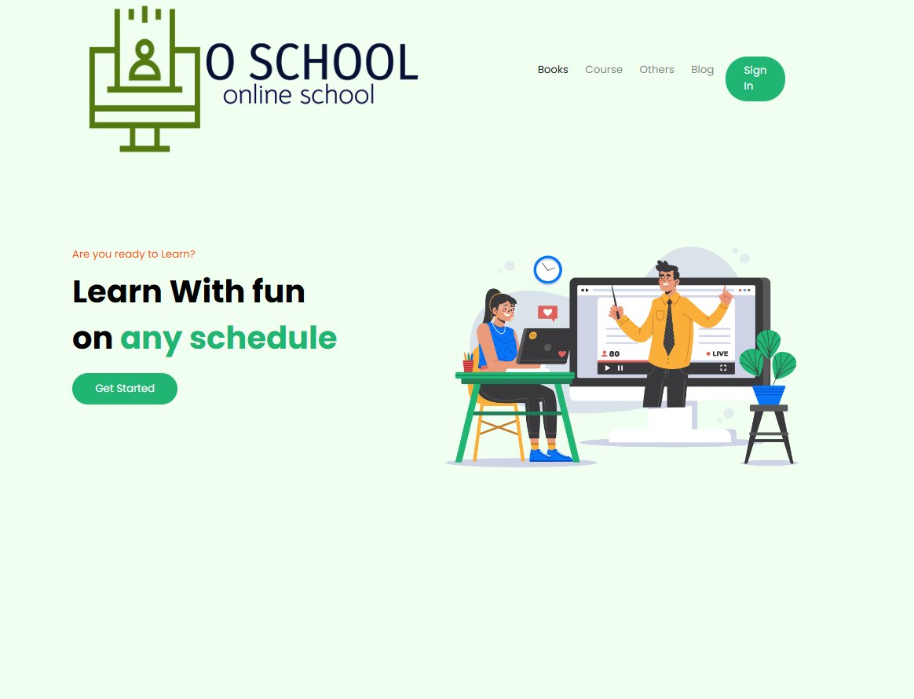

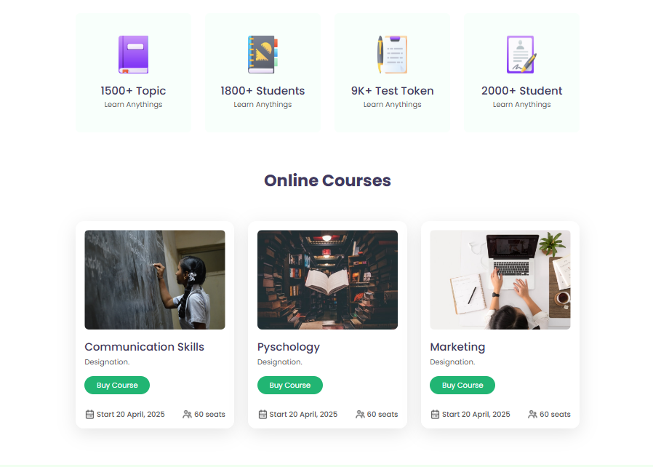

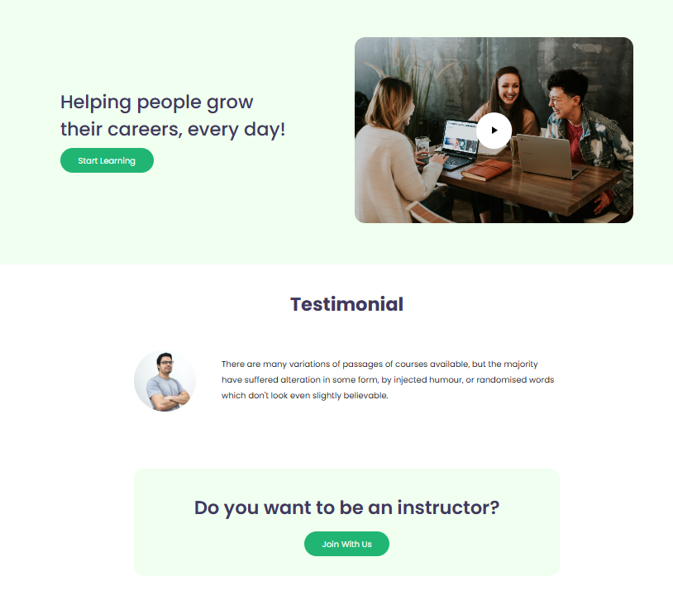

**CONCLUSION**

In conclusion, online schooling has transformed education, making it more flexible, accessible, and inclusive. By breaking down geographical and time barriers, online schools allow students to learn at their own pace, access a wider variety of courses, and develop digital literacy skills that are crucial in today’s world. While challenges such as maintaining engagement and ensuring equal access remain, the benefits of online schooling—customized learning experiences, convenience, and a wealth of resources—underscore its value. As technology and educational strategies continue to advance, online schooling will likely play an increasingly significant role in shaping the future of education.

REFRENCES

1. Chatgpt
2. W3Schools